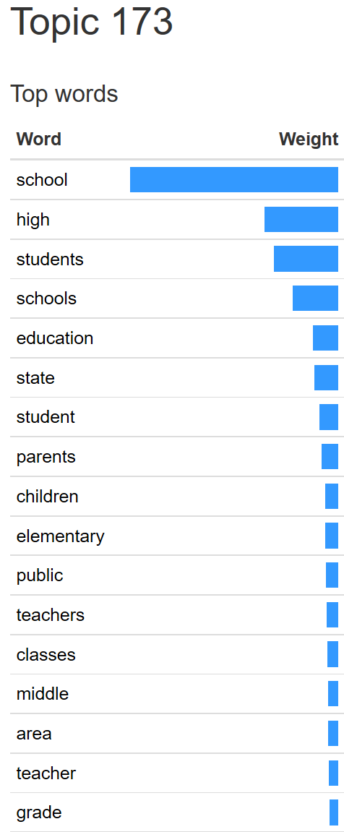
Case Study 3 -- Poor Match of Article to Topic
Model 1 -- 300-topics
Topic 173
Article: anonymous. “UPDATE: Murals To Be Displayed At Interim Site of Eastern Market.” The Washington Post. April 07, 2008. 338 tokens.

wp-2008-h-112,The Washington Post,2008-04-07T00:00:00Z,UPDATE: Murals To Be Displayed At Interim Site of Eastern Market,"One year after fire damaged the District's iconic Eastern Market, a dozen murals showing the market in all its glory will be unveiled at the temporary site where merchants have relocated.;The murals -- each a digital image five feet in diameter, made from an original painting or photograph -- will go up April 19, part of a public arts project sponsored by the D.C. Commission on the Arts and Humanities, said Executive Director Tony Gittens.;The 12 works will be installed on the wall of the temporary venue across Seventh Street SE from the gutted market building. After the market's restoration, estimated to cost up to $30 million, is completed next year, the digital images will be moved there. Donna Scheeder, chairwoman of the Eastern Market Community Advisory Committee, said contracts for the restoration work are awaiting the D.C. Council's approval.;The 10 artists whose work will be exhibited were selected in a competition judged by a panel.;They depict the Eastern Market and the strong, rich community around it,"" Gittens said.;All the selected artists had previously exhibited or sold their art at the 134-year-old market.;Each piece depicts a vibrant scene in or outside the historic building: firefighters chatting on the steps, a dairy merchant showing off a big wedge of yellow cheese, a woman buying vegetables, the market surrounded by vases of flowers, an old man playing the saxophone with rain falling in sheets in the background.;The art relates to the street vendors,"" said muralist Anne Marchand, whose paintings have been installed as part of a separate project at Eastern Market as it undergoes repairs. ""The images are all about renewal, spirit and the pride of the area,"" she said.;The artists whose work is on display are Mary Belcher, Michael Berman, Thomas Bucci, Victor Kinza, Matthew Parker, Val Proudkii, Zakhar Sasim, Quest Skinner, Joseph Snyder and Jonathan Blum.;The artists are quite excited,"" Marchand said, adding that she looks forward to watching regular shoppers react to the images when they ""stumble upon them"" for the first time.;Gittens said the exhibit aims to rally support for the market and its merchants.;Our hope is that the exhibit will help lift the spirits of those who continue to suffer from that loss,"" he said. ""The artists in the Eastern Market community have displayed a resilience and commitment which we applaud and look forward to supporting whenever possible.;-- Sopan

